High-Level Design Document

CUTime

Prepared For:

CSCI 3100, Software Engineering

Department of Computer Science and Engineering

The Chinese University of Hong Kong

Group: G2

Wong Man Chun (1155126073)

Hui Hiu Kit (1155143324)

Lau Yu Hin (1155143546)

Kwok Chun Yin (1155144588)

Tang Sunny (1155126459)

Table of Content

1 INTRODUCTION 3

1.1 Project Overview 3

1.2 Objective 3

1.3 System Features 3

2 BACKGROUNDS 4

3 SPECIFICATIONS 5

3.1 Data Flow Diagram 5

3.1.1 Login System 5

3.1.2 Timetable System 6

3.1.3 Friend System 6

3.1.4 Calculator System 7

3.1.5 Display System 7

4 SYSTEM ARCHITECTURE 8

4.1 Architecture Diagram 8

4.2 System Components 9

1. Login System 9

2. Timetable System 9

3. Friend System 10

4. Calculator System 11

5. Display System 11

# 1 INTRODUCTION

## Project Overview

CUHK Time (CUTime) is an online system aimed to help CUHK students to check their timetable validity in an easier manner. Without asking user to log-in or typing verification code every time, CUTime provides the same timetable information as the CUSIS and the official websites. The difference is user can customize the timetable according to their needs and they can connect with their friends by the in-built friend system. CUTime is so powerful and helpful that save a lot of time for student to check the validity of their timetable before the add-drop period.

## Objective

The timetable system provides a user-friendly environment for students to plan their timetable. It will show the course once it was selected. Users can check whether time clash exist in their timetable or are they available to register that course. Also, the user interface looks like the CUSIS so that user will not find difficulty to use it. The Login system prepare an information storing function for students. Users with an account can store the timetable information, GPA, and friends by using it. The friend system is to help students link with their classmates. Since CUHK students are studying online for almost 3 years, they may not be able to connect their classmates. The friend system allows user to add friend. Once they became friend on the system, they can view the timetable and profile of each other. Overall, it is a comprehensive system that tackle the timetable problem existing in the CUSIS.

## System Features

CUTime is constructed by timetable display, friend system and GPA calculator.

Timetable display is showing the timetable with the information of class code, course time, course venue, course instructor and course credit which will be displayed in the timetable frame in the system. Users can choose to show any of these information and customize the style of the timetable. They can save their personalized timetable to their device.

For the friend system and GPA calculator, it is only opened to register user. User can create an account for free and customize their timetable with the system.

In the friend system, users can check the profile and timetables of their friends, and even compare the timetable with them so that they can find the time that both are available and have gathering during that period.

The GPA calculator is to provide a simulation platform for user to check the GPA, including major GPA, CGPA. Although calculating GPA is simple, no one wants to spend time adding them one by one. So, the system will help you do this kind of job. You can even use it as a simulation purpose to check the grade needed to get the expected GPA. These features will help CUHK students to plan their study career easily.

# 2 BACKGROUNDS

In the Chinese University of Hong Kong, a course timetable is the main schedule for students. For each semester, students need to register for new courses that they would like to study. However, it is inconvenient to manage our timetable in the CUSIS system using the shopping cart system, so our group would like to develop a webpage CUTime that can provide a faster way to plan and validate timetables.

Students also like to share their timetables to their friends so that they can know the schedules and common courses of each other, to plan their study group and activities out of classes. Normally, students will share their timetables via WhatsApp, but it is inconvenient for checking timetables of different friends from time to time. Therefore, CUTime provides a friend function which simplifies referencing timetables but also provides a brand-new way for establishing friendships with people sharing common courses prior to the lessons.

# 3 SPECIFICATIONS

## 3.1 Data Flow Diagram

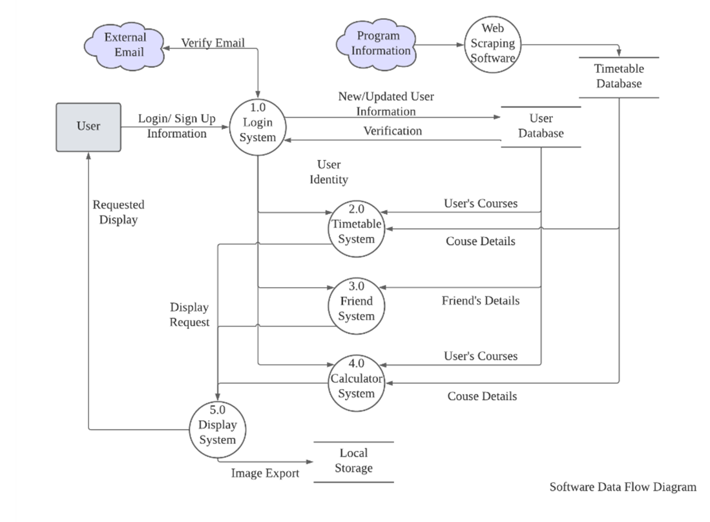

### 3.1.1 Login System

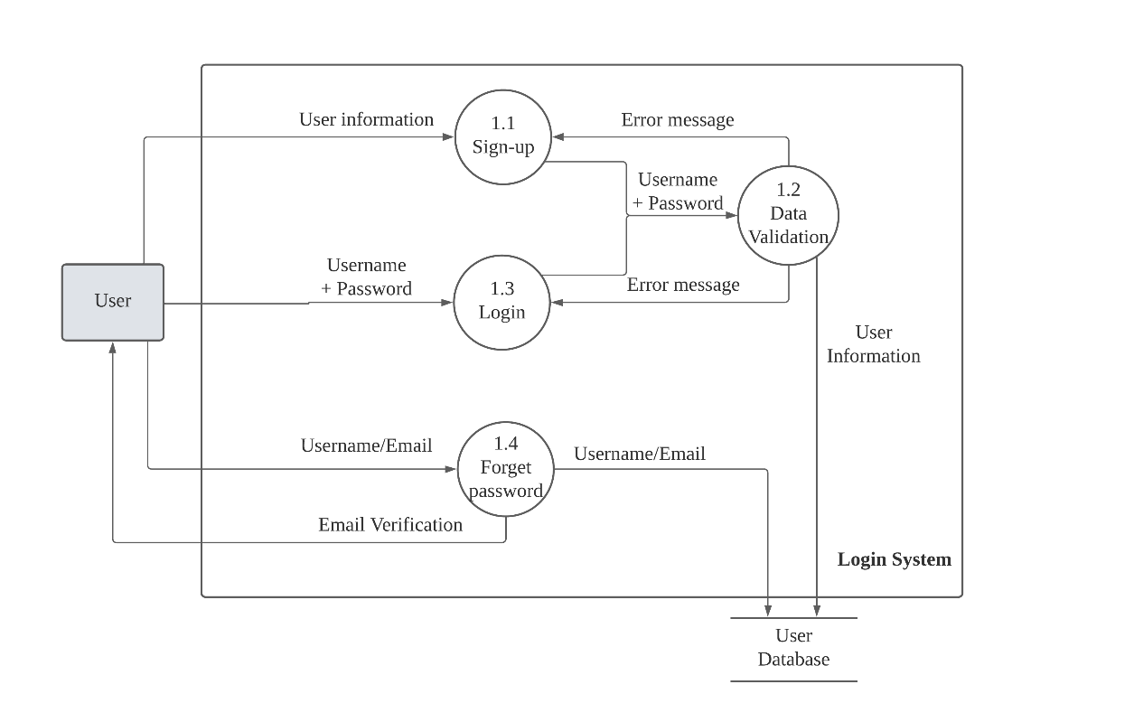

### 3.1.2 Timetable System

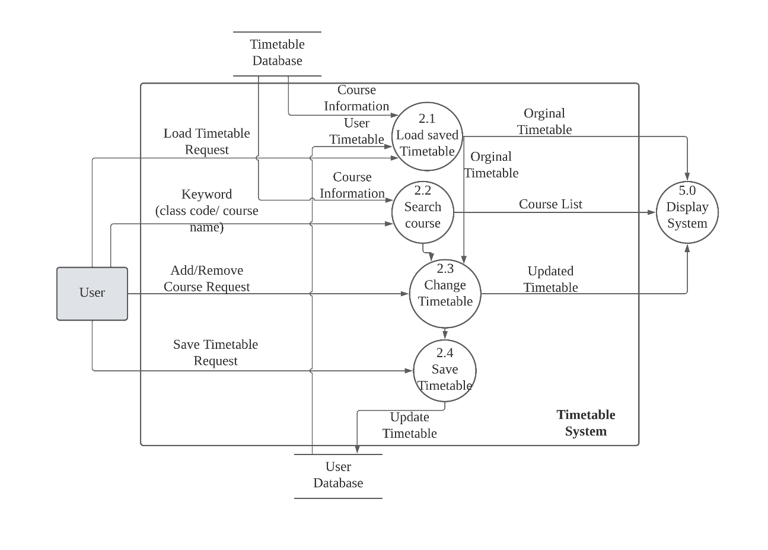

### 3.1.3 Friend System

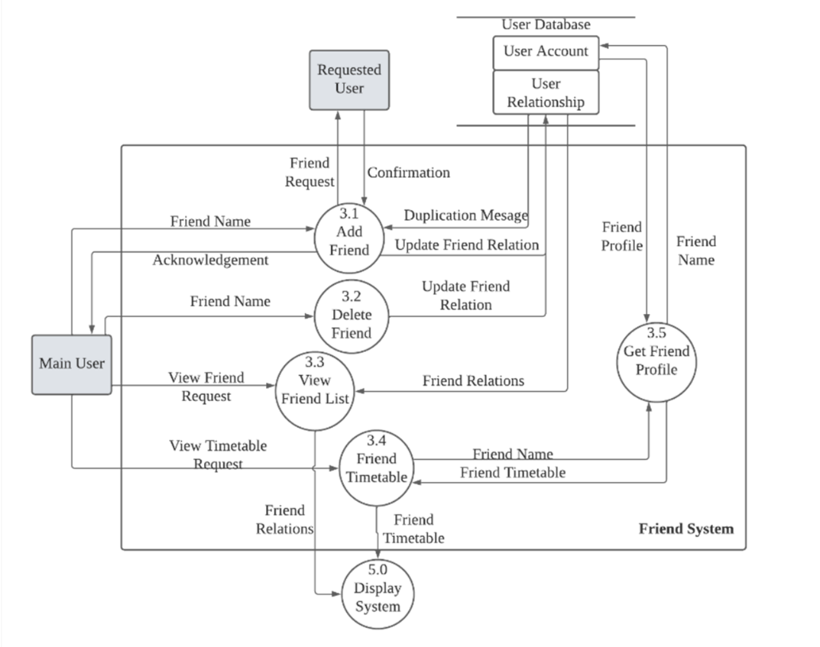

### 3.1.4 Calculator System

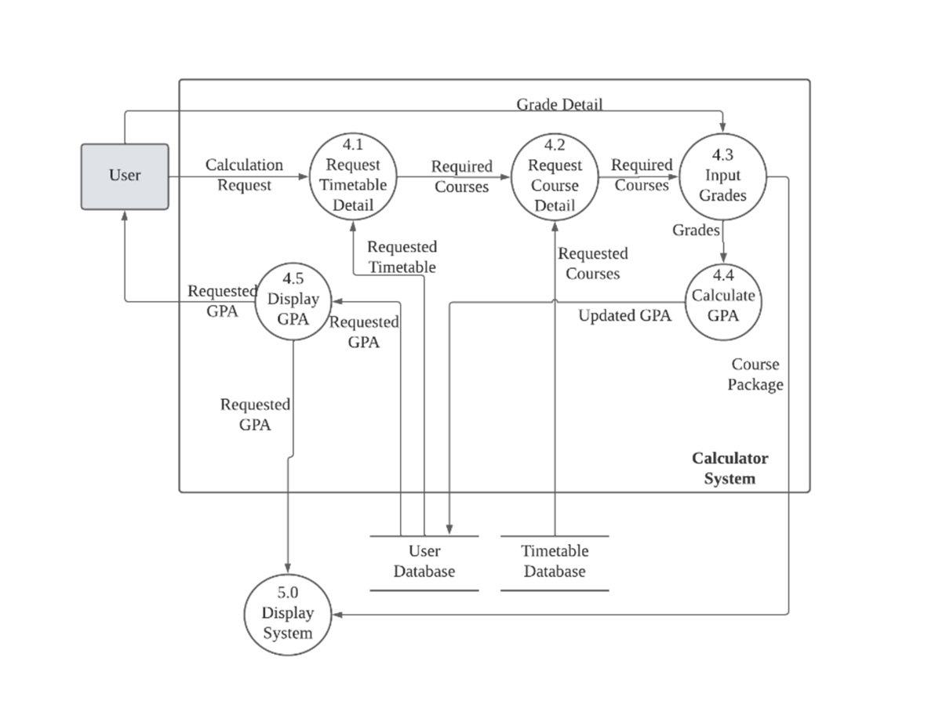

### 3.1.5 Display System

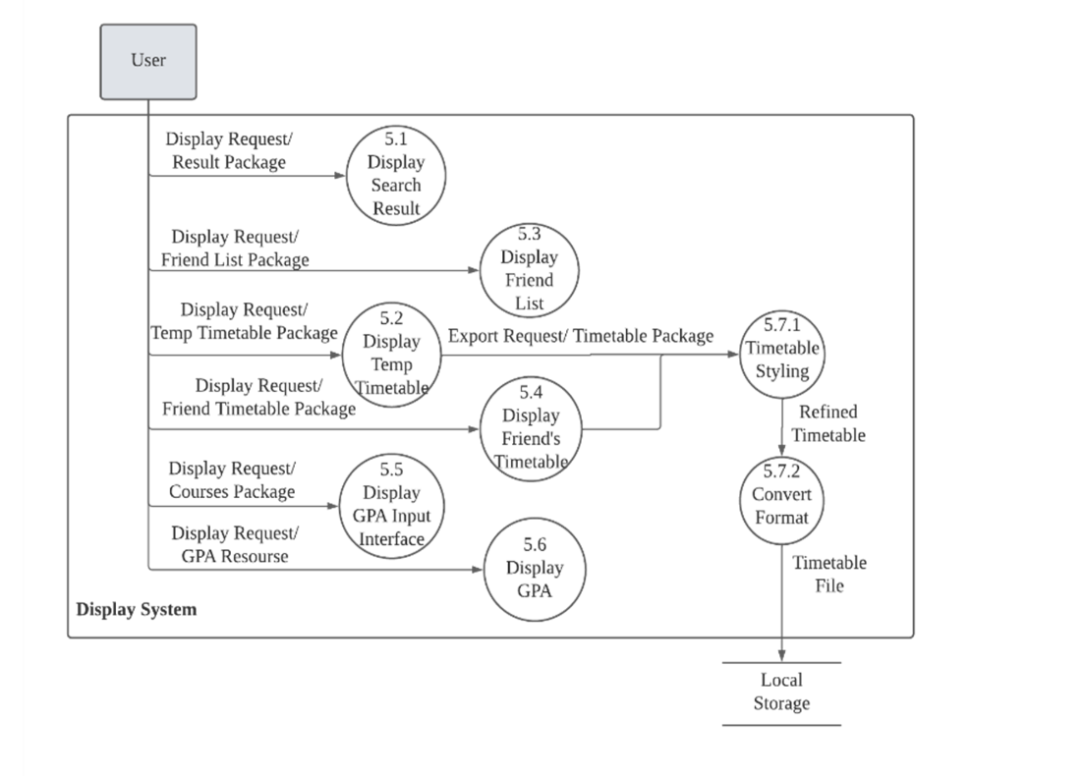

# 4 SYSTEM ARCHITECTURE

## 4.1 Architecture Diagram

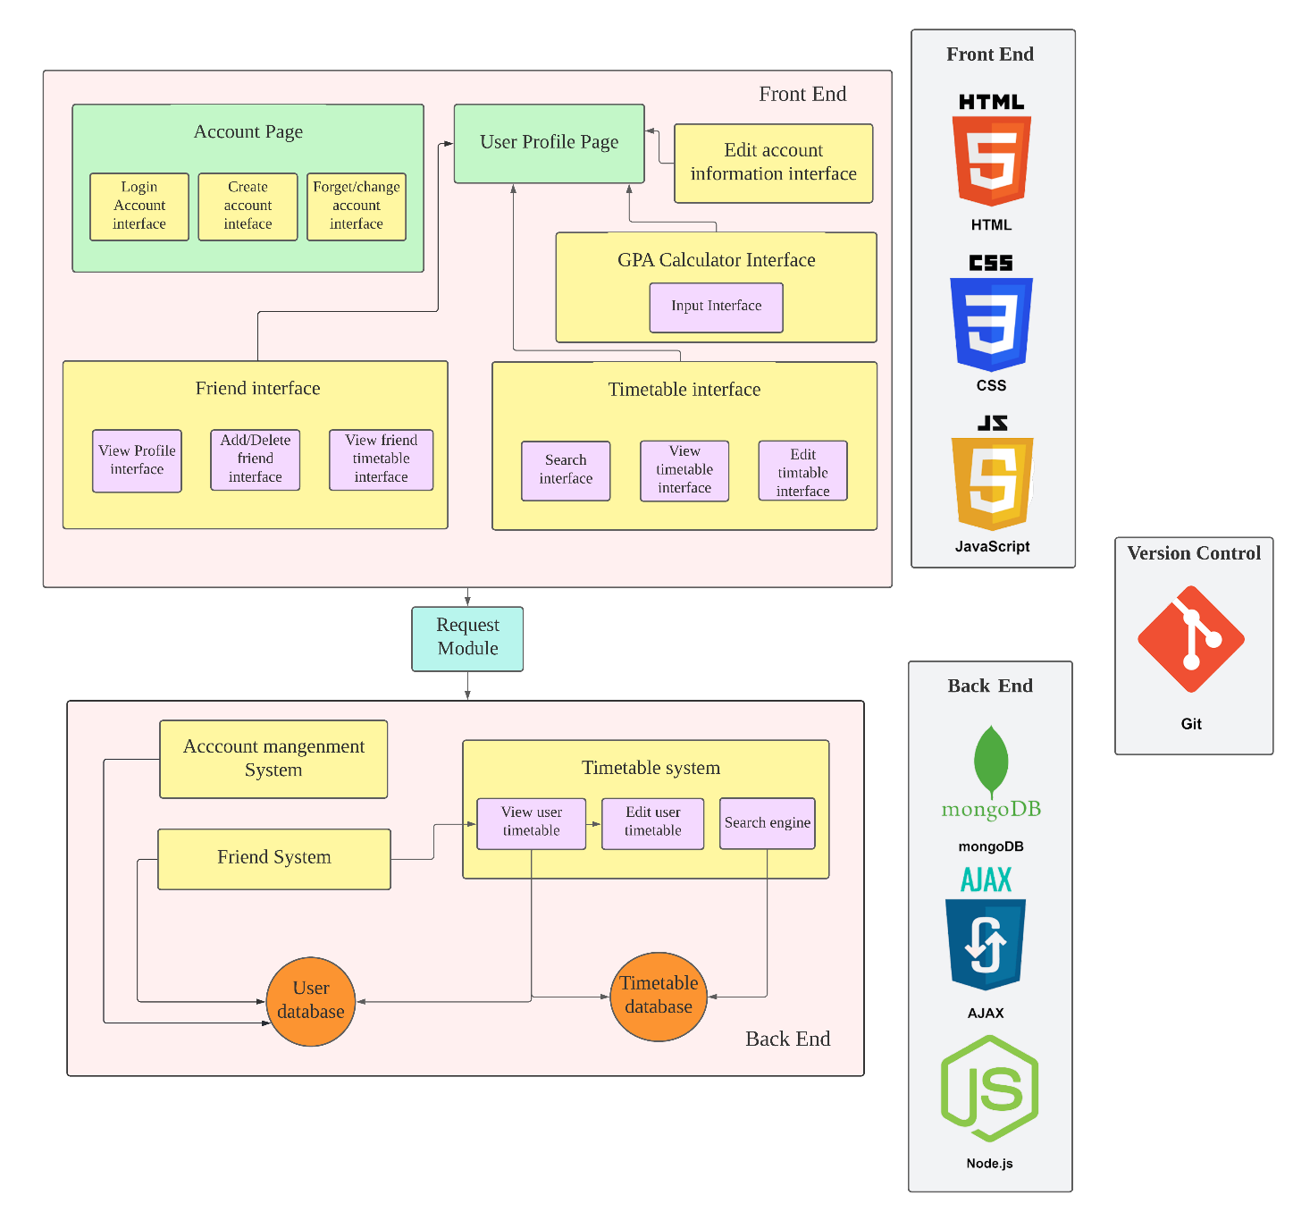

## 4.2 System Components

### 1. Login System

* 1. Sign-up

New user will be asked to create an account with some basic information, including email address, username, password, etc.

* 1. Data Validation

For data flow from the Sign-up (1.1), the system will check is there any missing or unreasonable information. If it passed the checking, the information will be stored in the user database, the account is successfully registered. An error message will be sent if something is unsatisfied.

For data flow form the Login (1.3), the system will check the inputted username and password with the data in the user database. If the inputted data is matched with the database, the user will be logged in to the system. If the information is mismatched, it will send an error message.

* 1. Login

Existing user can login in by typing the username and password.

* 1. Forget Password

If the existing user forgot the login information, he/she can type the email address or the username in the system, and the system will check the corresponding email address and send a temporary password to the user which he/she can log in into his/her account in the Login (1.3).

### 2. Timetable System

2.1 Load Saved Timetable

Once the user is logged in to the system, it will load the saved timetable of the user from the timetable database and user database.

2.2 Search Course

User can search for the course he/she is looking for by searching the class code. The system will search it from the timetable database. And display the result to user in the Display Search Result (5.1).

2.3 Change Timetable

User can manage the existing records in the timetable. Users are also able to add the search result from the Search Course (2.2) to the timetable. The result of the edited timetable will also display in the Display Search Result (5.1).

2.4 Save Timetable

When user is finished editing the timetable, he/she can save the timetable information to our database. Once the request is sent by user, the user database will be updated coordinately.

### 3. Friend System

3.1 Add Friend

User can send friend request to other users to add them as friends. After the confirmation, user will receive an acknowledgement and they can be friends, friends can then share timetable or GPA to each other through the systems.

3.2 Delete Friend

User can delete any friend from the friend list, and it will update to both users accounts, so they cannot share any information anymore.

3.3 View Friend List

User can also request to view the friend list and to see the total number of friends and also their username too, afterwards they can view friends’ timetable by the Friend Timetable (3.4) function.

3.4 Friend Timetable

User can choose to view the friends’ timetable by entering their username, then the Get Friend Profile (3.5) function will get the course that friend took and send the course information to the Display System (5.0). Finally, the user can view friends’ timetable.

3.5 Get Friend Profile

The system will help load the friends’ profile and return the courses that the friend took back to the Friend Timetable (3.4) Function.

### 4. Calculator System

4.1 Get the Class Code

The system will get the class code from the user database. And output in two directions, one going to the Get the Course Information (4.2) with the class code only, another going to the Gades Input (4.3) with the class code and stored grade.

4.2 Get the Course Information

The system will get the course information including course credit and course name according to the class code from the user database.

4.3 Grades Input

User will be directed to a new page in the Display GPA Input Interface (5.5) that show all the course they added in the timetable with an option menu that user can choose the grade of them.

4.4 GPA Calculating

Once the user clicked the “calculate my GPA” button in the Grades Input (4.3), the GPA and the corresponding grades will be calculated and uploaded to the database.

4.5 GPA Display

The system will show the display GPA (5.6). If the user was directed from the Grades Input (4.3), user will see this page after clicking the “calculate my GPA” in the Grades Input (4.3) Also, user can request to display the GPA of him/her directly after the Login (1.3).

4.6 Share to Friend

User can share the GPA of him/her to his/her friend in the CUTime.

### 5. Display System

5.1 Display Search Result

The system will receive request from the Timetable System (2.0) and the relevant package: including the keyword that the user input and related courses. Then display the search result in html manner.

5.2 Display Temporary Timetable

The system will receive request from the Timetable System (2.0) and the relevant package: including user current selected courses and corresponding courses details. Then display the timetable in html manner.

5.3 Display Friend List

The system will receive request from the Friend System (3.0) and the relevant package: including user relations and friend list. Then display the friend list in html manner.

5.4 Display Friend's Timetable

The system will receive request from the Friend System (3.0) and the relevant package: including user friend list, designated friend's selected courses and corresponding courses details. Then display the friend timetable in html manner.

5.5 Display GPA Input Interface

The system will receive request from the Calculator System (4.0) and the relevant package: including user courses recorded and corresponding courses details. Then generate the GPA input UI in html manner.

5.6 Display GPA

The system will receive request from the Calculator System (4.0) and the GPA resource. Then generate the GPA in html manner.

5.7 Convert the Temporary

5.7.1 Timetable Styling

When Export request is received, the related timetable information will proceed to the styling process. User can select the course information to shown, font, font size, color, background, border etc. The Style will integrate with the timetable data and convert to designated format

5.7.2 Covert Format

User can select the format of the export file, such as png, jpg, pdf, xlxs etc. The converted file will then download to users' local storage